IMM_VHDX 4.14.1 Installation Process

- Download the “IMM_Windows_4.14.1.zip” from the Download site
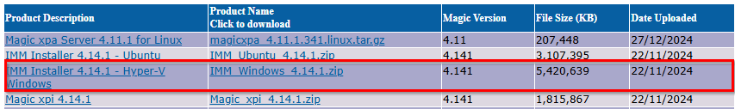
- Keep the Power Shell scripts and VHDX zip file in a single folder, say <drive>\magic\imm-vhdx.task
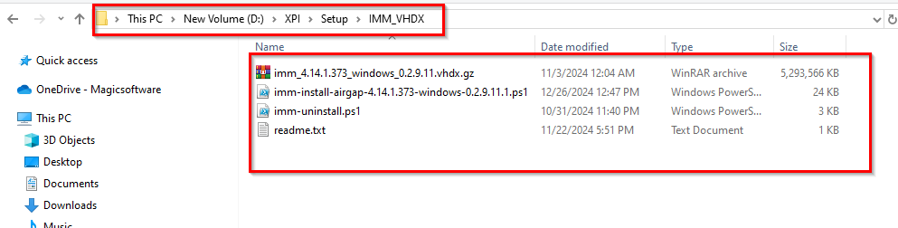
- Make sure the Hyper-V is enabled on your system.
- Check if any previous installation of IMM VHDX is present.
- If yes follow the below steps:
  - Run the .\imm-uninstall.ps1 %Path to create the log% -flagPurge $true from the
i.e. .\imm-uninstall.ps1 c:\magic\immvhdx\log -flagPurge $true
  - It will ask “Are you sure you want to remove virtual machine "IMM-Instance"?” Type A and Press Enter
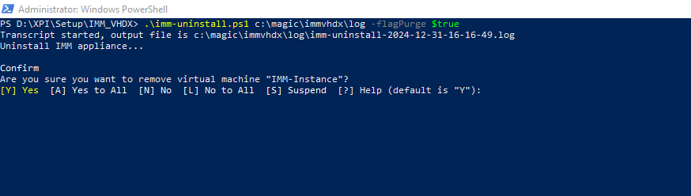
  - It will again ask for the confirmation Press A and Press Enter
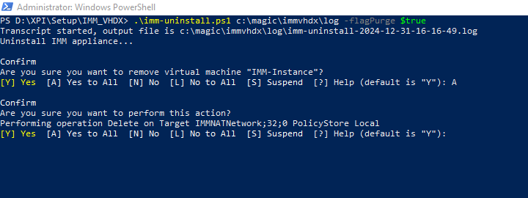
  - It will complete the process stating “Uninstallation complete”
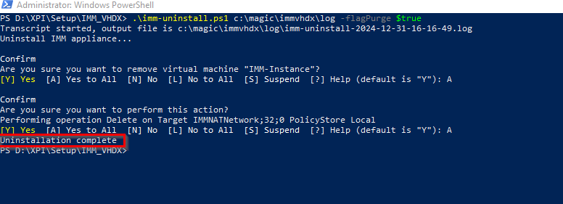
- After removing old IMM VHDX installation Run the netstat -a and check if Port 80, 6379, and 27017 are not used, as this port are must.
- If the machine has IIS installed then it should be running on port other than 80.
- TO change the IIS port follow the below steps:
  - Open IIS and go to the Default site
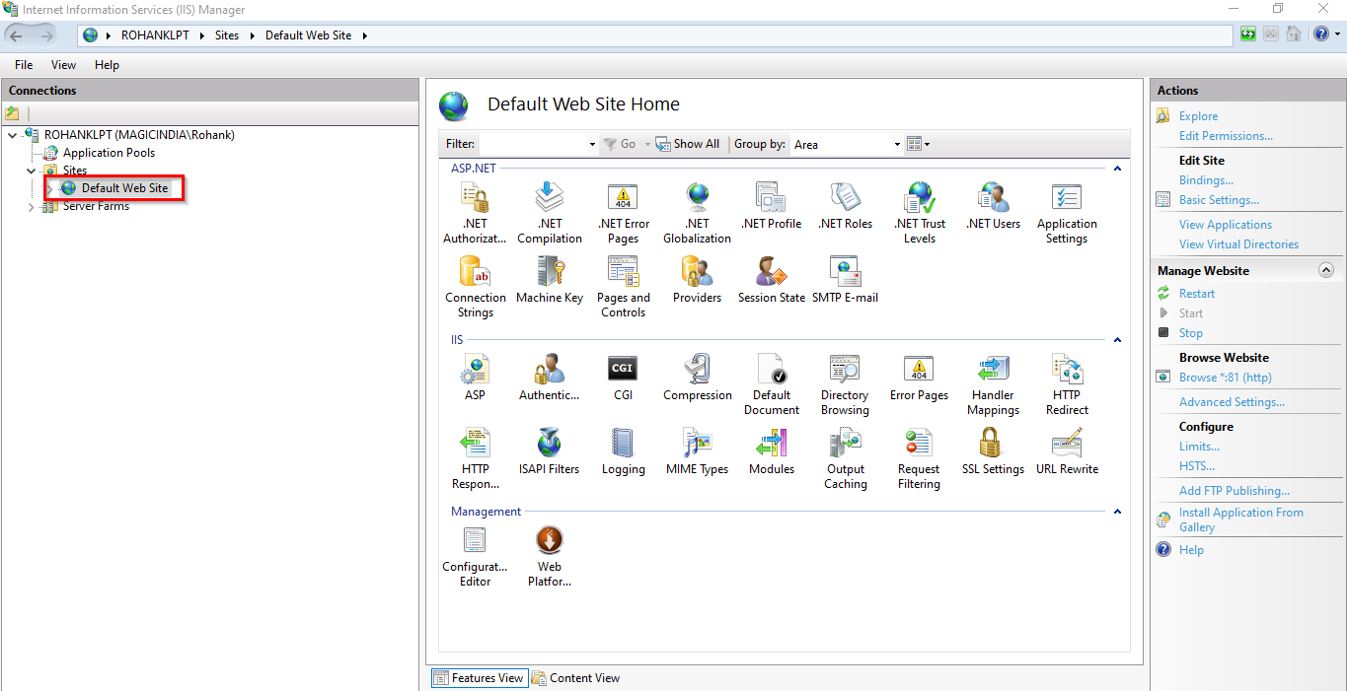
  - Open on bindings
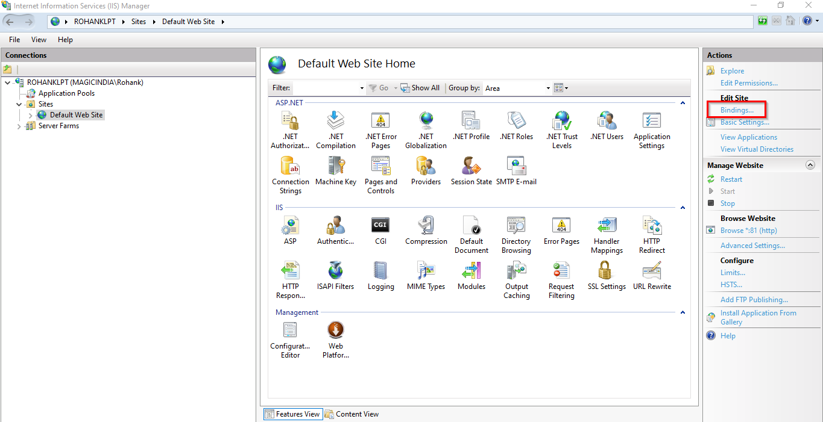
  - Edit the http port and change it to 81
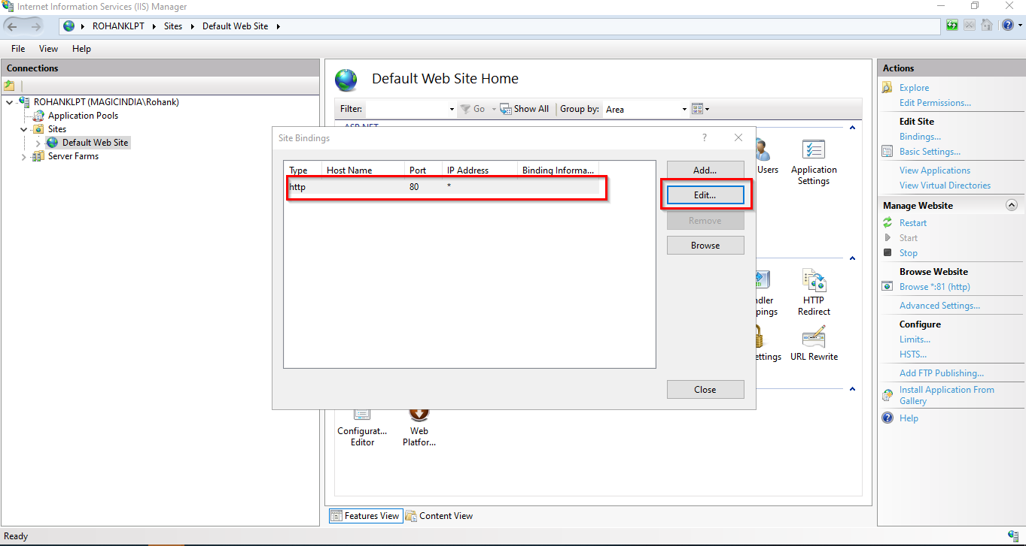
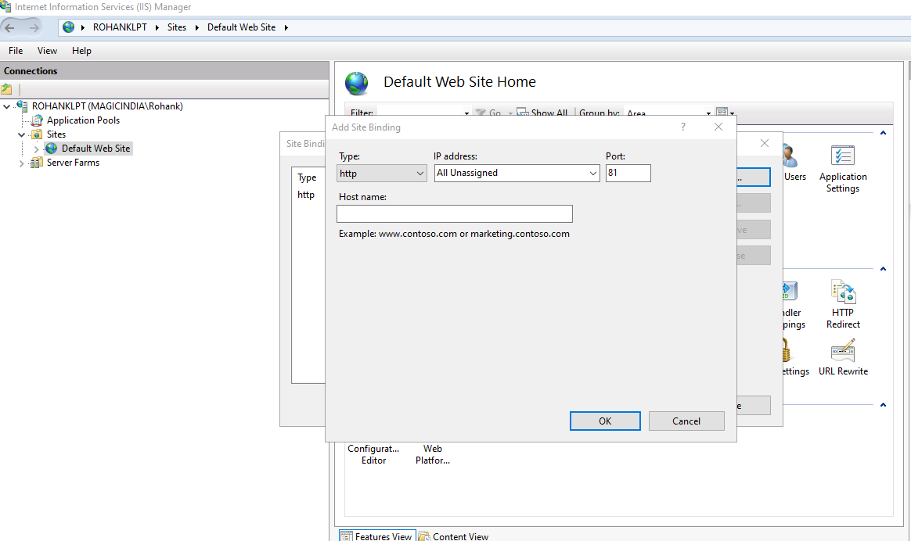
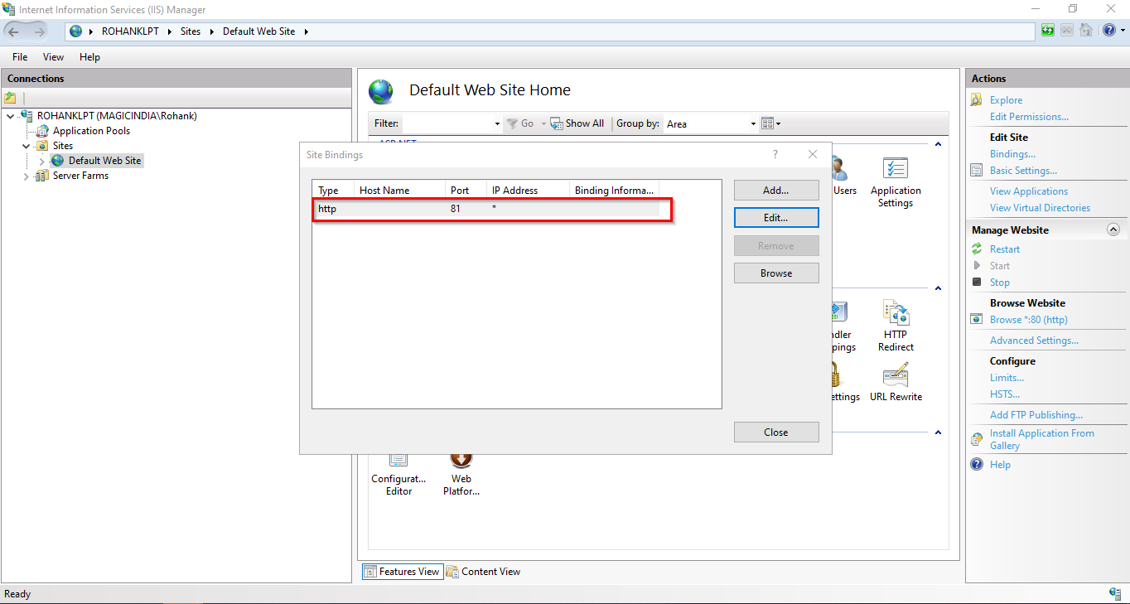
  - After making this changes reset the IIS
- Follow Below steps to install IMM VHDX
  - Run the “imm-install-airgap-4.14.1.373-windows-0.2.9.11.1.ps1”
  - It will ask for the “artefactPath” Give the folder path of the location where you copied the imm_4.14.1.373_windows_0.2.9.11.vhdx.gz and press Enter
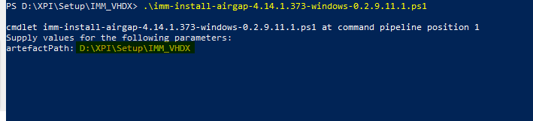
  - It will start the installation process.
  - It can take upto 20 minutes to complete
  - Once the installation complete it will give the Monitor URL and other details
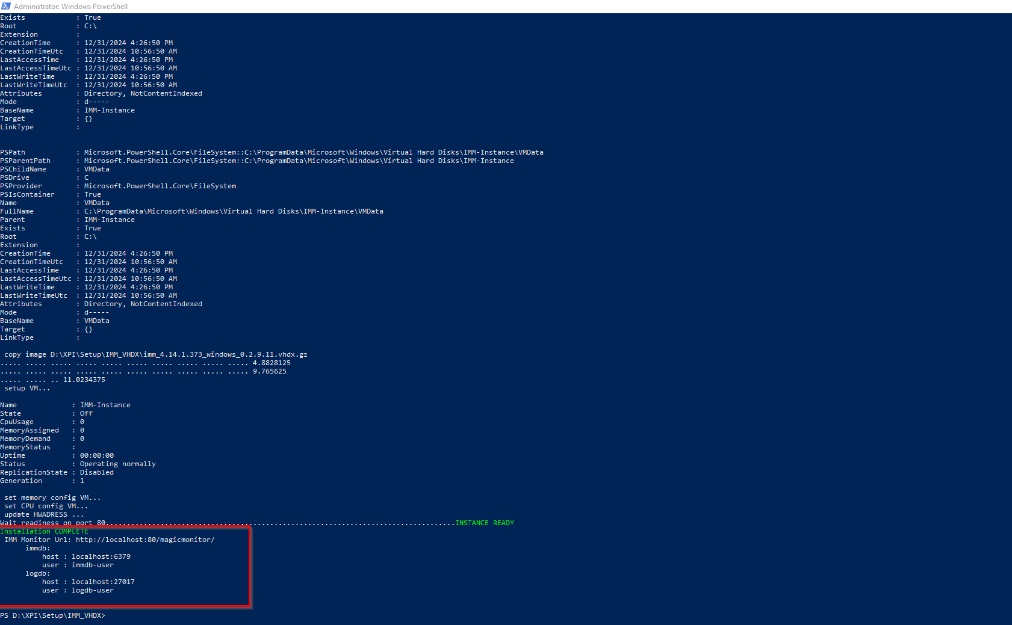
- Once the installation is complete you can login to the Monitor using http://localhost/magicmonitor/
- The Credentials for the IMM VHDX are as follows:
  - login to VHDX
    - CLi User: root
    - CLi Pass: Magic-IMM
    - Static IP - 10.126.254.250
  - login to Redis and MongoDB
    - IMMDB_USERNAME : immdb-user
    - IMMDB_PASSWORD: Jdhto82xns

    - LOGDB_USERNAME: logdb-user
    - LOGDB_PASSWORD: lkdTxsk392

